**Lesson 9 Demo 04**

**Clustering**

**Business Scenario:**

A well-known travel company wants to expand its customer base. The company's branding manager needs to devise an effective scheme to appeal to potential customers. He needs to analyze the life expectancy and population of each country to help the company identify the countries where the right kind of clientele is present.

* Which cluster will you choose and why?

**Overview:**

* Use the saved world indicators data source
* Create a filled map view
* Create a calculated field to show the money that the people of a country spend annually on international travel
* Add a cluster to the view
* Select describe clusters to view the information

The result should resemble the image given below:

**Detailed Instructions:**

1. Open **Tableau 10.x** (You can go to Start Menu -> All Programs -> Tableau 10.x)

1. Connect to the **World Indicators** sample data source

1. From dimensions, double-click on **Country**

1. Using the **Marks** card, change the mark type to **Map**

The result will be displayed as:

1. Go to the **Analysis** menu and select **Create Calculated Field**

1. Name this calculation as **Tourism Per Capita**

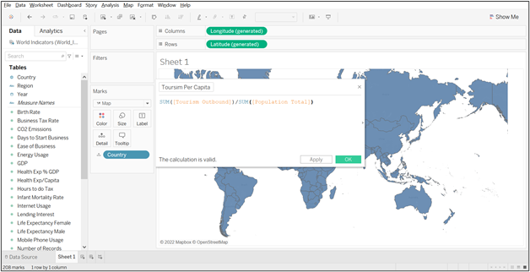

1. In the formula window, enter formula as:

**SUM([Tourism Outbound])/SUM([Population Total])**

1. From measures, drag **Population Urban, Population 65+,** and **Tourism Per Capita** to **Detail**

1. Select the average aggregation for the first two measures

1. To cluster the data points, navigate to the **Analytics Pane**

1. Drag **Cluster** from the **Analytics** pane and drop it into the view. Tableau displays the cluster dialog box and adds the measures in the view to the list of variables

1. Close the **Clusters** dialog box by clicking the **X** in the upper-right corner

1. Click the **Clusters** field on the **Marks** card and choose **Describe Clusters**

1. Close the **Describe Clusters** dialog box

Rename this sheet as **Clustering.**

## Answers:

1. Which cluster will you choose and why?

Answer: **Cluster 2**. It has the highest values in all aspects.